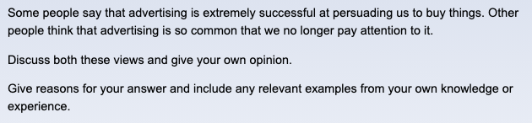

**题目争论：一些人认为广告在说服我们购买上是非常成功的；另一些人则认为广告太常见了以至于我们都不再关注它。**

**题目要求：讨论双边并给出自己的看法**

With the dramatic increase of media channels, commercial advertisements are often used as marketing tools for increasing purchases and profits. In my opinion, while advertisements are persuasive for customer behavior changes, people's reliability to certain brands may exceed the willingness of trying what suggested in advertisements in some situations.

There is a common sense that giant companies usually have a large amounts of advertising budgets when stimulating purchase, which reveals the importance of advertisements in persuading people. As campaigns are launched, brands have chances to remind customers what they could add to daily life, and more importantly, they will give discounts for more consumptions. The 11.11 festival held by Taobao is a suitable example. Without rationality, some people may buy products in large discounts but not indispensable in daily day in double eleven, being unconsciously influenced by this commercial campaign.

Nevertheless, some groups are too reliable for specific brand to try what are persuaded in common advertisements. For example, though commercial campaigns are launched for new cellphone brand frequently, iPhone fans still have a highly attachment to Apple series products rather than switching to other cellphone brands. It is obvious that though advertisements can attract target groups to some extent, the previous products have established unique competence, not only the unique iOS operation system but also machine quality, making it possible for Apple consumers become devoted to the single brand

To sum up, advertisements indeed have influence on customers who have no determined ideas in what to buy, but they are useless to groups who show ignorance to common advertisements for specific brand preference.

字数：264